

**ACL Prevention Program**

**Perform 3x a week**

**Week 1: Day 1**

Dynamic Warm Up: (10 min)

Jog for 5 minutes. Follow with stretching of the groin, hip, quads, hamstrings, and calf muscles or as instructed by your athletic trainer. Perform each stretch 2 times for at least 30 seconds.

Strengthening:

Alternating Bent Knee Fall out (60 seconds)

Alternating Hip and Leg Extensions (60 Seconds with 3 sec hold)

Squats– focus on technique (2x10)

Side lying hip abduction (2x10)

Side lying Clam shell (2x10)

Balance:

Single leg balance – focus on leg alignment (3x30sec)

Single leg balance with figure 8 ball movement (3x30sec)

Plyometrics:

Squat Jumps (5x30ft)

Broad Jumps (5x30ft)

**Week 1: Day 2**

Dynamic Warm Up: (10 min)

Jog for 5 minutes. Follow with stretching of the groin, hip, quads, hamstrings, and calf muscles or as instructed by your athletic trainer. Perform each stretch 2 times for at least 30 seconds.

Strengthening:

Alternating Bent Knee Fall out (60 seconds)

Alternating Hip and Leg Extensions (60 Seconds with 3 sec hold)

Squats (2x10)

Side lying hip abduction (2x10)

Side lying Clam shell (2x10)

Balance:

Single leg balance on foam mat – focus on leg alignment (3x30sec)

Single leg balance with volley or ball toss (3x30sec)

Single leg balance during 4-way hip with band (2x10 each way)

Plyometrics:

Squat Jumps (5x 30ft)

Double Leg Tuck Jumps – focus on landing properly (2x30sec)

Lateral Jumps – speed skater (2x30sec)

Agility:

Zig-Zag jog with pause at plant and cut (5x30ft)

**Week 2: Day 1**

Warm Up: (10 min)

Jog for 5 minutes. Follow with stretching of the groin, hip, quads, hamstrings, and calf muscles or as instructed by your athletic trainer. Perform each stretch 2 times for at least 30 seconds.

Strengthening:

Plank/ Side Plank (60 sec)

Bridge (60 sec)

Squats on foam mat (3x10)

Sidestepping (5x30ft)

Balance:

Single leg balance – focus on leg alignment (4x30sec)

Single leg balance on airex pad/foam mat with volley or ball toss (4x30sec)

Plyometrics:

Double leg depth jump (15x)

Lateral Jumps – speed skater (3x30sec)

Double leg Jump onto airex pad/ mat (30x)

Agility:

Plant and Cut (5x30ft)

**Week 2: Day 2**

Warm Up: (10 min)

Jog for 5 minutes. Follow with stretching of the groin, hip, quads, hamstrings, and calf muscles or as instructed by your athletic trainer. Perform each stretch 2 times for at least 30 seconds.

Strengthening:

Plank/ Side Plank (60 sec)

Bridge (60 sec)

Foam mat squat and hold (3x10 hold each squat for 10 secs)

Sidestepping (5x30ft)

Balance:

Single leg balance on airex pad with volley (4 x 30sec)

Bird Dips (2x30sec each leg)

Plyometrics:

Single leg depth jump (15x each leg)

Lateral Jumps – speed skater (3x30sec)

Double leg Jump onto airex pad/mat (30x)

Agility:

Plant and Cut (5x30ft)

**Week 3:**

Warm Up: (10 min)

Jog for 5 minutes. Follow with stretching of the groin, hip, quads, hamstrings, and calf muscles or as instructed by your athletic trainer. Perform each stretch 2 times for at least 30 seconds.

Strengthening:

Plank/ Side Plank (60 sec for plank or 30 sec each side for side plank)

Single Leg Bridge (30 sec each leg)

Side Stepping (3 x 45 sec)

Walking Lunges (3x 50 ft)

Nordic Rocking (30 sec -> 60sec)

Balance:

Single leg balance on airex pad with volley or ball toss (4x45 sec each leg)

Bird Dips (2x45 sec each leg)

Plyometrics:

Double leg depth jump onto foam mat (30x)

Bunny Hops (5x10)

Double leg Jumps with header/set/catch and pass (2x30 sec)

Agility:

Side stepping over cones (2x30sec)

**Week 4:**

Warm Up:

Jog for 5 minutes. Follow with stretching of the groin, hip, quads, hamstrings, and calf muscles or as instructed by your athletic trainer. Perform each stretch 2 times for at least 30 seconds.

Strengthening:

Side Plank (45 sec each side)

Plank with Leg with Leg Lifts (45 secs)

Single Leg Bridge (45 sec each leg)

Nordic Hamstring (2x30 sec)

Reverse Lunges (3x50ft)

Monster Walk (5x30 ft)

Balance:

Single leg balance on airex/foam mat with ball toss (2 x 1 minute each leg)

Cone Taps (2x 1 min each leg)

Plyometrics:

Double leg Jumps with 180 degree turn (2x20)

Single leg Depth Jump onto airex pad/foam mat (30x each leg)

Double leg depth jump with header/volley/set/catch and pass (30x)

Agility:

Shuttle add Carioca (5x30ft)

**Week 5**

Warm Up: (10 min)

Jog for 5 minutes. Follow with stretching of the groin, hip, quads, hamstrings, and calf muscles or as instructed by your athletic trainer. Perform each stretch 2 times for at least 30 seconds.

Strengthening: (15 min)

Side Plank with leg lifts (60 sec)

Plank with arm and leg lifts (60 sec)

Single Leg Bridge(45 sec each leg)  
 Nordic Hamstring Half (3x10)

Split Squat (2x10 each leg)

Balance:

Cone Taps with Ball Catch (2x1min each leg)

Plyometrics:

Single leg depth jump onto foam mat with volley/set/catch and pass (30x each leg)

90 degree jumps (2x20)

Agility:

Jog and cut (3x50ft)

**Week 6**

Warm Up: (10 min)

Jog for 5 minutes. Follow with stretching of the groin, hip, quads, hamstrings, and calf muscles or as instructed by your athletic trainer. Perform each stretch 2 times for at least 30 seconds.

Strengthening:

Side Plank with leg lifts (60 secs)

Plank with Arm and Leg Lifts (60 secs)

Nordic Hamstring Full (3x10)

Single leg squat on foam mat (3x15 each leg)

Balance:

Balance Pad war (3x30 sec)

Jumping:

Single Leg Triple Hop (10x each leg)

Box Hops double leg and single leg (10x each leg)

9o degree Jumps (2x20)

Agility:

Jog and Cut (3x50ft)

***Exercises Explained***

***Strengthening:*** Make sure you activate your core muscles while performing this exercise. To activate your core muscles, attempt to bring your belly button closer to your spine by contracting your deep abdominal muscles

**Bent Knee Fall Out**

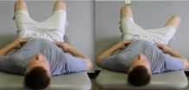Lay on back with knees bent. Tighten abdominals as if a bowling ball were about to be dropped on abdomen. Be sure to not hold your breath. Do not tighten abdominals in a way that will change the neutral position of the spine. Slowly and under control, let one leg fall out to the side while maintaining pelvis in neutral. Return leg to starting position and perform on the other side. Relax.

Make sure each repetition starts with a new abdominal contraction and alternate the starting side.

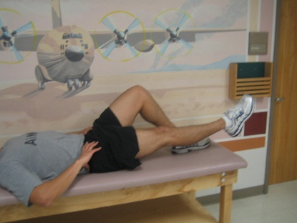**Alternating Hip and Leg Extensions**

While lying on your back with knees bent, straighten out one knee while keeping the leg off the ground. Hold as indicated, then return to original position. Next, perform on the other leg.

Use your stomach muscles to keep your spine from moving the entire time.

**Side Lying Hip Abduction (Leg Lifts)**

While lying on your side, slowly raise up your top leg to the side. Keep your knee straight and maintain your toes pointed forward the entire time. Hold for 3 seconds at the top

The bottom leg can be bent to stabilize your body

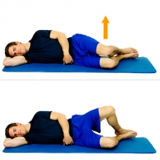**Clam Shell**

While lying on your side with your knees bent, draw up the top knee while keeping contact of your feet together. Do not let your pelvis roll back during the lifting movement. Hold for 3 sec at the top.

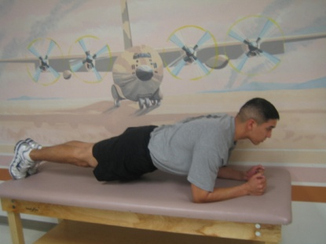**Plank**

While lying face down, lift your body up on your elbows and toes. Try and maintain a straight spine. Do not allow your hips or pelvis on either side to drop.

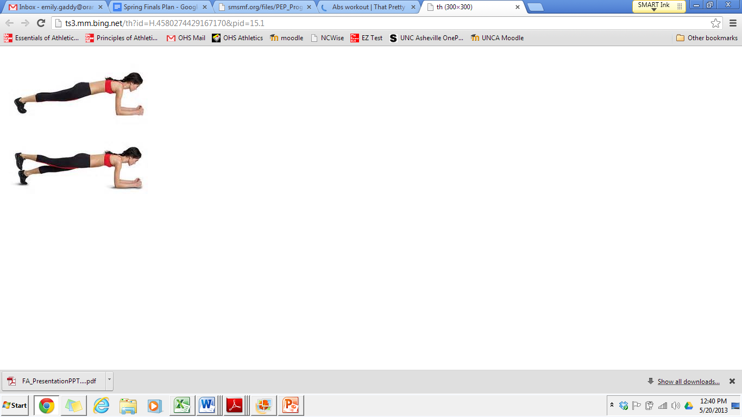

**Plank with Leg Lift**

While lying face down, lift your body up on your elbows and toes. Next, lift up one leg. Return to original position and then perform with the other arm and leg. Try and maintain a straight spine.

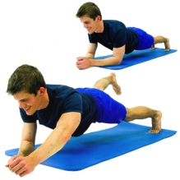**Plank with Arm and Leg Lift**

While lying face down, lift your body up on your elbows and toes. Next, lift up one arm and opposite leg. Return to original position and then perform with the other arm and leg. Try and maintain a straight spine.

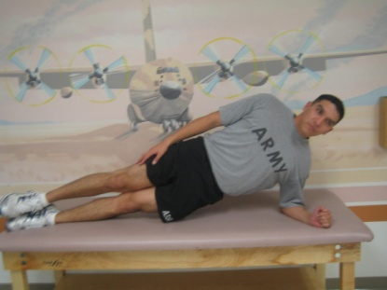

**Side Plank**

Begin laying on your side with legs stacked one on top of the other. Bring your forearm to the mat as pictured with your elbow directly under your shoulder. Raise your hips up into the air into a side plank as pictured. Hold this position.

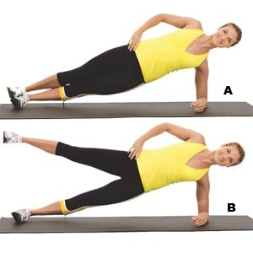**Side Plank with Leg Lift**

Come into side plank position with one elbow on the ground and inside of your foot. Lift arm straight up and then lift leg straight up.

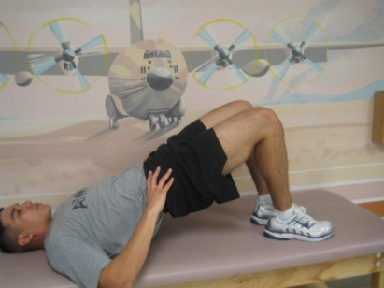**Bridge**

Draw abdominals in, lift hips, pushing through your feet, until your knees, hips and shoulders are in a straight line. Tighten your bottom muscles as you do this. Maintain neutral spine.

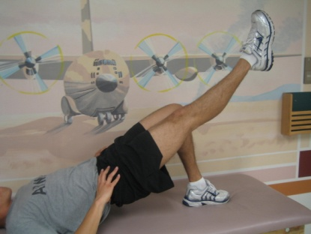

**Bridge with Leg Lift**

Draw abdominals in, lift hips, pushing through your feet, until your knees, hips and shoulders are in a straight line. Tighten your bottom muscles as you do this. Maintain neutral spine and straighten one leg, do not allow hips to drop or pelvis to tilt.

**Side-Stepping:**

Place band around ankles and separate legs so that there is adequate tension. Place body in a ½ squat position and take a large step to the left, leading with the left leg and then a small step with the right to keep the tension on the band.

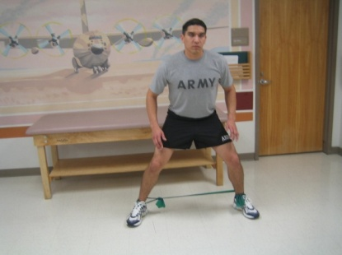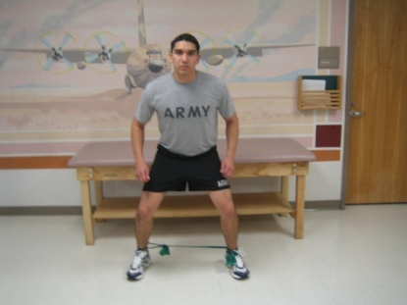

↔

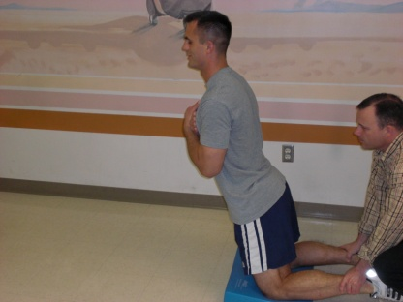**Nordic Rocking**

Slowly rock forward and backwards with ankle supported. Bend from the knee and keep the back in a neutral position.Only lean as far forward as you feel comfortable.

**Nordic**

With a partner, slowly lower yourself. Only go as far as you feel comfortable. Bend from the knee and keep the back in a neutral position.

**Nordic Half**

With a partner, slowly lower yourself about halfway down before catching yourself in the push-up position. Bend from the knee and keep the back in a neutral position.

**Nordic Full**

With a partner, slowly lower yourself down as far as you can before catching yourself in the push-up position. Bend from the knee and keep the back in a neutral position.Perform 3 sets of 10 repetitions.

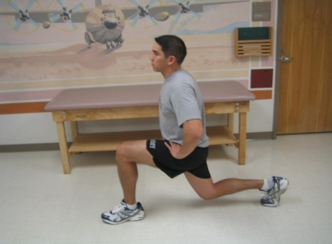**Lunges**

Stand with good posture, keeping the back straight. Step left leg forward, ensuring that your knee does not go over your toe. Let right knee bend until you are in the ending position. Step forward and repeat with right leg Do not touch the knee to the ground.

**Reverse Lunges**

Stand with good posture, keeping the back straight. Take a large step backwards with the flexed leg. Lower your back knee into a lunge position. Return to the starting position without allowing the foot to touch the ground.

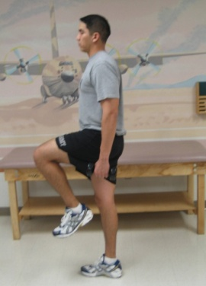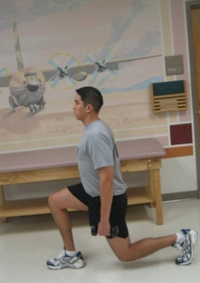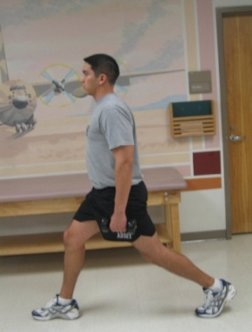

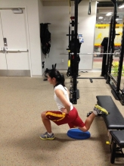

**Split Squat**

Place your back foot on a box or bench and step out into a lunge. Lower your hips toward the floor by squatting back and down without letting your back knee touch the ground return to the starting position by driving your weight back up with your front leg

***Balance:***

**Single Leg Stance with Figure 8**

Stand on one leg while performing a figure 8 movement with the ball and you other leg. To increase the difficulty, stand on a pillow.

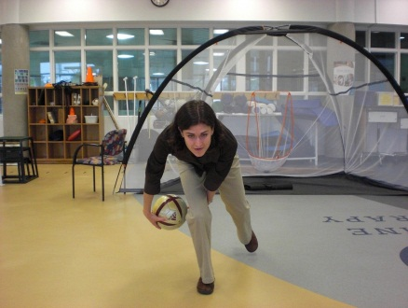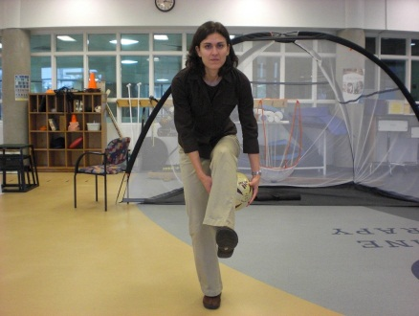

↔

**Single Leg Stance with Band**

Stand on one leg in each direction while performing small kicks with the band on the other leg.

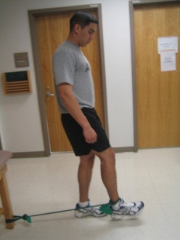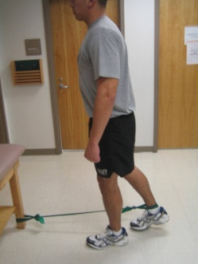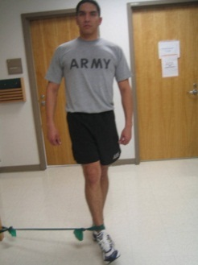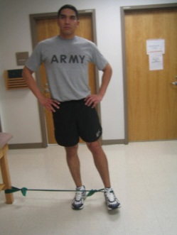

**Bird Dips**

Stand upright with good posture. Slowly bend forward and lightly touch one hand to the ground (keep the stationary knee soft- do NOT lock out the knee, while the opposite leg extends behind you. Slowly come back up to the starting position, keeping hips level. Perform this exercise slowly, emphasizing on maintaining balance.

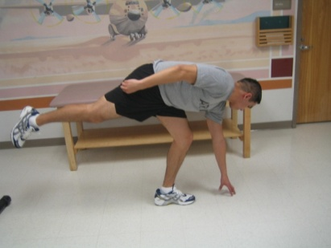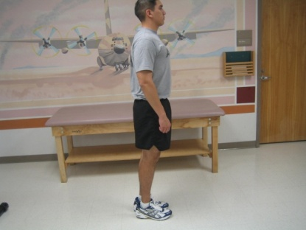

↔

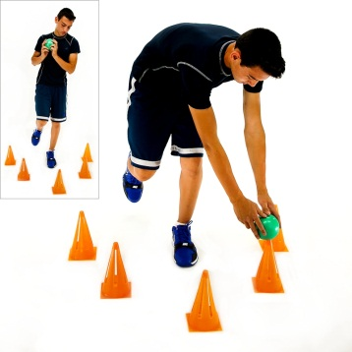**Cone Taps**

Place 5 cones, markers, or cups around you as shown. Balance on a slightly bent knee. Holding a ball, lower yourself down to tap the top of a cone with the ball. Return to original position and repeat touching a different cone. Keep both hands on the ball the entire time. Advance exercise with smaller cones/cups and or faster speed.

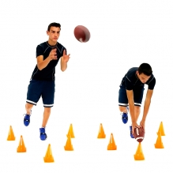**Cone Taps wit Ball Toss**

Place 5 cones or cups around you as shown. Balance on a slightly bent knee. Catch a ball, lower yourself down to tap the top of a cone with the ball. Throw the ball back. Repeat touching a different cone. Keep both hands on the ball as you tap the cone. If you do not have a partner, throw a ball against a wall. Advance exercise with smaller cones/cups and or faster speed.

**Balance War**

With a partner, stand on one leg facing each other. Attempt to lightly push your partner to have them loose their balance. To increase the difficulty, stand on a pillow. Perform for 5 min.

# Plyometrics

**Double Leg Jumping**

Hop as far as you can with two legs making sure to focus on proper form and knee alignment.

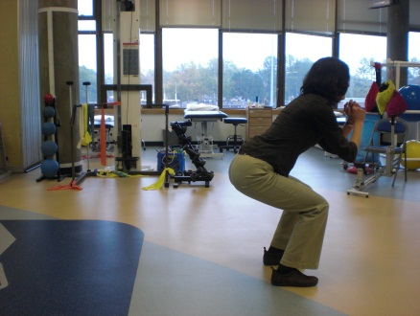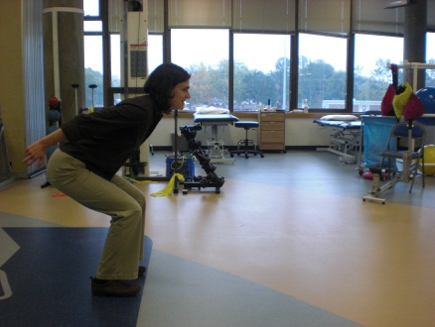

↔

**Speed Skater**

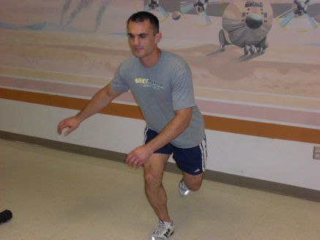Begin in a partial squat with the weight focused through your heel, quads, glutes and abs doing most of the work. Knee stays behind and in line with your big toe. Start by taking large steps side to side and focus on controlled decceleration, gradually increase the size and speed of steps until they are jumps. If you cannot control the landing or if there is pain you are jumping too far.

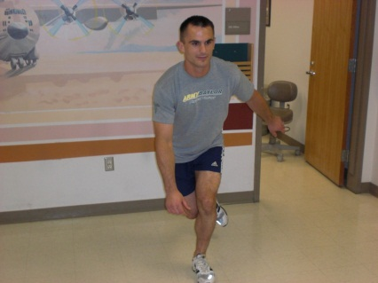

↔

# 

# Single/Double Leg Depth Jump

# Stand on a step with both feet. Walk off the step and land on a single/double leg absorbing the impact through your whole lower body. Remember to land softly and control your knee maintain good stability throughout your body.

# Shuttle Run Drills

# Pick a starting line and then 2-3 spots at approximately 10-15 foot intervals from the start line. You will use those spots as markers to run to. Start by running to the first mark then back to start, to second mark, then back to the start, etc

Perform the exercise in the following directions with emphasis on good stability and control of your knee with changing directions:

Forward/backwards (i.e. run forward to the first spot, back ward to the start line, forward to the second line, backward to the start line)

Side step: keep knees bent and stay low to get maximum quad workout

Carioca: Cross-over stepping

**Bunny Hops:** Hop forward 5 times and backwards 5 times over a cone. Remember to land softly and control your knee maintaining good stability throughout your body. Repeat 5 times

**180 deg Jumps:** Jump with good form and turn in the air so you are facing the alternate direction. Remember to land softly and control your knee maintaining good stability throughout your body. Perform 2 sets of 20 repetitions.

**90 deg Jumps:** Jump off of both legs with good form and perform a quarter turn in the air and land on one foot. Remember to land softly and control your knee maintaining good stability throughout your body

# Jog and Cut: Jog in a zigzag pattern, going about 15 feet before changing direction. Use proper cutting technique emphasizing good stability and control of your knee as you change directions. Perform 5 sets of this exercise.

# Single Leg Triple Hop: Stand on one leg and jump as far as you can. Immediately flowing jump an additional time on a single leg then finally jump and land on both legs. Perform 10x paying attention to good knee stability and control.

**Box Hops:** Jump up on a box with both legs. Next, jump down with both legs followed by a broad jump for distance. Maintain good stability and control in your knee. Perform 10 repetitions. You can increase the difficulty by performing on one leg.