Shoulder/Elbow Injury Prevention Program
Flexibility
Hold for 30 seconds and perform 2 repetitions.
Open Book:
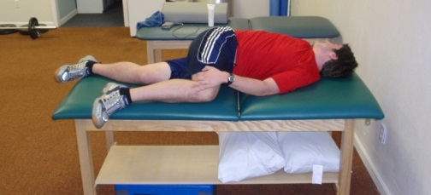
- Lie on table (or ground) on your side with your bottom leg straight and your top knee bent.
- Place your bottom hand on your top knee and press into one another with about 20% effort.
- Rotate your top arm around you and follow it with your eyes.
- Make sure to breath throughout exercise and don’t allow your top knee to leave the table.
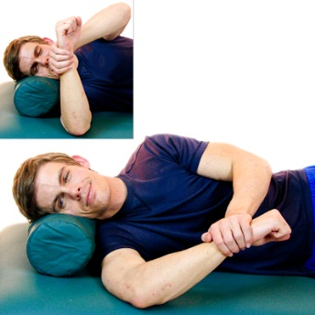
Sleeper Stretch:
- Lie on your side with your bottom arm out in front of you and your elbow bent to 90 degrees.
- Lightly press your hand down towards the table until you feel a stretch in your shoulder.
Prayer Stretch
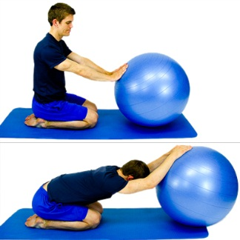
- Start in kneeling position with your hands on a chair/stool/ball.
- Bring your hips back to your heels and reach your arms out in front of you.
- Drop your chest down to the ground keeping your arms straight.
- Your body weight should be mostly on your heels and away from your hands.

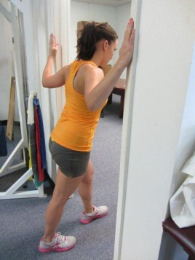
Doorway Stretch
- Stand in doorway with shoulders and elbows at 90 degrees.
- Place one foot through the doorway, it doesn’t matter which foot you use.
- Lean through doorway putting weight on forward foot.
- You should feel the stretch in your chest close to your shoulders.

Towel Internal Rotation Stretch
- Hold towel in both hands with one arm behind your back and the other hand holding the top of the towel.
- Pull towel up over your shoulder using upper hand.
- Slide lower hand up your spine keeping the hand in contact with your back the whole time.
- You should feel a stretch in the shoulder of the arm that is behind your back.

Wall Hamstring Stretch
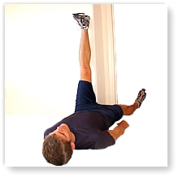
- Lie on your back with one leg up on a wall with your heel and back of your knee touching the wall.
- Slowly lower your opposite leg until you feel a stretch in the leg that is on the wall.
- Don’t allow your knee on the wall to bend or your low back to come off the ground.
- Hold this end point and then slowly return to the starting position.
Toe Touch Toe Ups
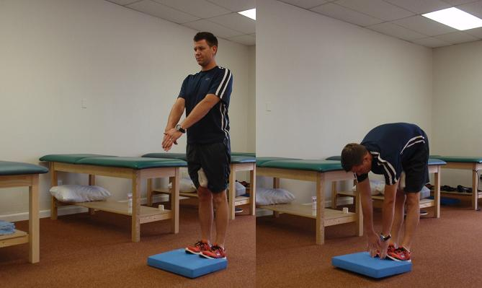
- Start in a standing position with your toes up on a small object and a large towel roll between your knees.
- Squeeze the towel as you bend forward reaching for your toes.
- Only reach as far as you can while keeping your knees straight.
- Hold the stretch position and then slowly return to the starting position.
- Avoid performing if you have any low back issues and feel a tingling into your feet.
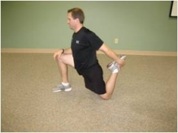
Kneeling Quad Stretch
- Start in kneeling position with knee on cushion or rolled up towel.
- Reach back and grab your foot, pull it towards your buttocks.
- Shift your weight forward onto front leg until you feel a stretch in the front of your thigh
- If you find yourself falling over hold onto an object.
- Hold the stretch position and then slowly return to starting position.

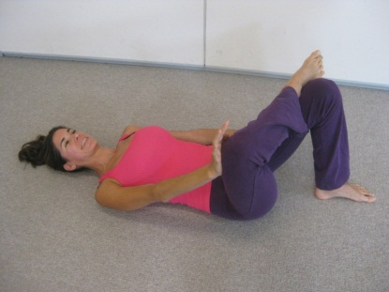
Figure 4 Stretch
- Start lying on your back and cross one leg over the other.
- Grab behind the leg that is in contact with the table.
- Pull that knee towards your chest until you feel a stretch in the hip that is crossed over.
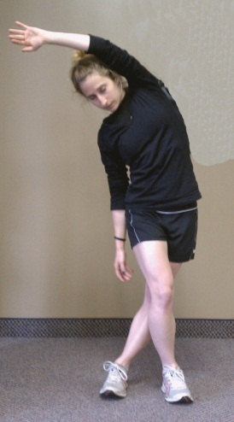
- Hold the stretch position and then slowly return to starting position
Crossover ITB Stretch
- Start with one side towards a wall and cross the outside leg behind the leg that is closest to the wall.
- Put both hands on the wall and lean so your hip goes away from the wall.
- You should feel a stretch in the outside hip.
- Hold the stretch position and then slowly return to starting position.
- You should feel like you are making a big C with your body. Keep feet close to wall to allow for this position to occur.
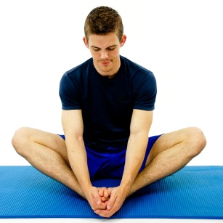
Butterfly Stretch
- Start in seated position with feet facing each other.
- Hold onto feet with your hands and drop knees towards the ground lightly pushing with your elbows until you feel a stretch in your inner thigh muscles.
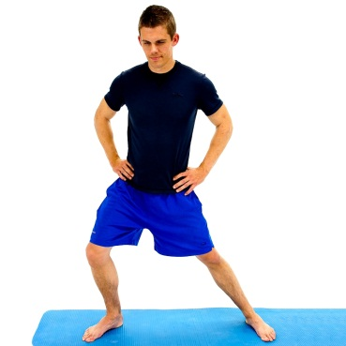
Standing Groin Stretch
- Start in standing position with feet spread far apart.
- Shift towards one of your feet while keeping the opposite knee straight.
- Hold the stretch position and then slowly return to starting position.
- Don’t allow your bent knee to go in front of your toes.
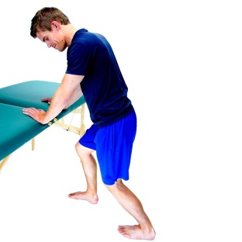
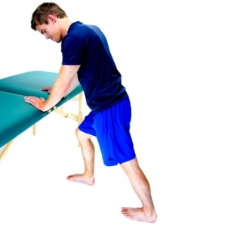
- Don’t allow your hip to pass over the foot you are moving towards.
Standing Calf Stretch (Gastroc and Soleus)
- Stand and lean against a wall
- Place one foot back behind you and bend the front knee until a gentle stretch is felt on the back of the lower leg.
- Your back knee should be straight the entire time. (Gastroc)
- After holding for 30 seconds bend your back knee and hold for an addition 30 seconds. (Soleus)

Strength/Stability
Perform 3 sets of 10 repetitions for the exercise unless otherwise noted. The exercises progress from easiest to hardest. Start with the easiest one and then progress to the next exercise when it becomes too easy.

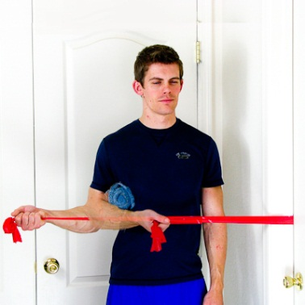
Rotator Cuff
Shoulder External Rotation (Easy)
- Stand with arm across body and elbow against your side holding onto tubing.
- Attach tubing to object or close in door frame.
- Rotate your arm away from your body keeping the elbow touching your side.
- Do not turn your body. Create the motion in your shoulder only.
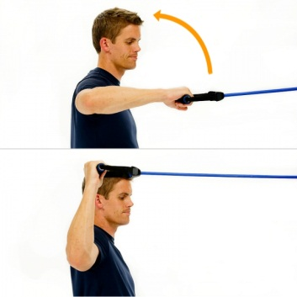
Shoulder External Rotation 90/90 (Medium)
- Stand facing the door with your elbow and shoulder at 90deg of bend.
- Anchor tubing to object or close in a door.
- Pretend there is a pin through your elbow that goes into your shoulder. Rotate your arm back around that pin so your forearm ends perpendicular to the ground.
- Do not arch your back or rotate your body to create the movement.
Shoulder External Rotation 90/90 in Lunge (Hard)
- Perform 90/90 ER motion in Lunge position.
- Get into pitching release position. If you are right handed your left leg should be forward and your right leg back. Reverse for left handed pitcher.
- Stay in lunge throughout the exercise.
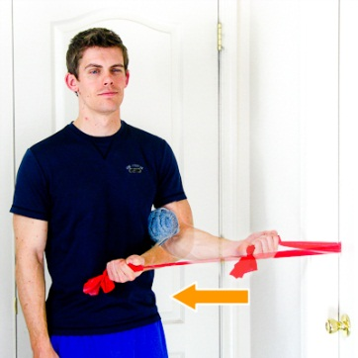
Shoulder Internal Rotation (Easy)
- Stand with arm out to side and elbow against your side holding onto tubing.
- Attach tubing to object or close in door frame.
- Rotate your arm towards your body keeping the elbow touching your side.
- Do not turn your body. Create the motion in your shoulder only.
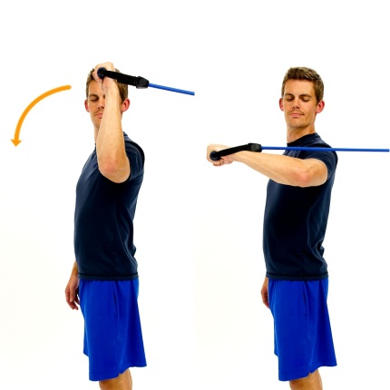
Shoulder Internal Rotation 90/90 (Medium)
- Stand facing away from the door with your elbow and shoulder at 90deg of bend.
- Anchor tubing to object or close in a door.
- Pretend there is a pin through your elbow that goes into your shoulder. Rotate your arm forward around that pin so your forearm ends parallel to the ground.
- Do not arch your back or rotate your body to create the movement.
Shoulder Internal Rotation 90/90 with Lunge (Hard)
- Perform 90/90 IR motion in Lunge position.
- Get into pitching release position. If you are right handed your left leg should be forward and your right leg back. Reverse for left handed pitcher.
- Stay in lunge throughout the exercise.

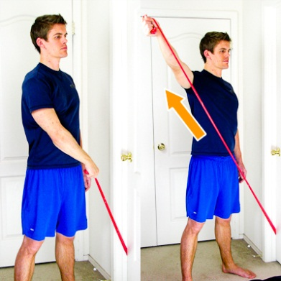
D2 Flexion Standing (Easy)
- Stand with tubing in hand and under opposite foot.
- To start thumb should be pointing at hip.
- Bring your arm up and out like you are drawing a sword from a sheath. Your thumb should be pointing behind you now.
- Keep elbow straight throughout exercise.

D2 Flexion in Lunge (Hard)
- Get into lunge position (pitching release point) with tubing in hand and secured to object or under a closed door.
- To start thumb should be pointing at hip.
- Bring your arm up and out like you are drawing a sword from a sheath. Your thumb should be pointing behind you now.
- Keep elbow straight throughout exercise. Stay in lunge position throughout exercise.

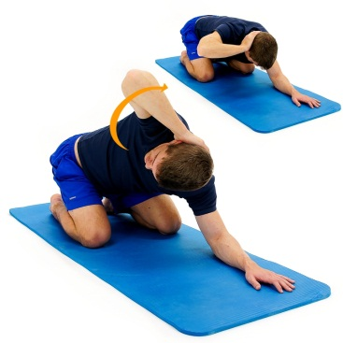
Quadruped Torso Turns
- Start on your hands and knees with one hand behind your head.
- Rotate that elbow up towards ceiling following it with your eyes.
- At the top position you should feel like you are pressing your opposite hand into the ground with about 20% effort.

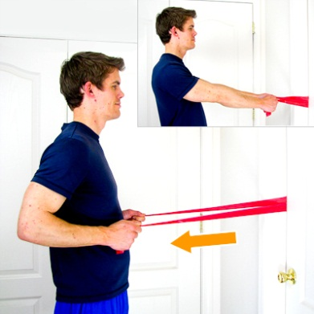
Alternating Row
- Start in standing position holding onto loops of the tubing. The tubing should be secured in door.
- Pull one arm back like you are starting a lawn mower and press the other hand towards the door.
- You should feel like you are rotating your shoulders as much as you can without moving your hips.

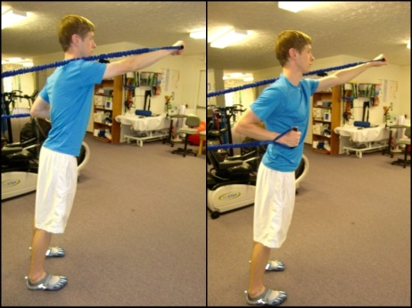
Alternating Press
- Hold onto the ends of the tubing in standing position with your back to the door. Make sure tubing is secure in door frame.
- Press one hand forward as other hand goes backwards towards wall.
- You should feel like you are rotating your shoulders as much as you can without moving your hips.
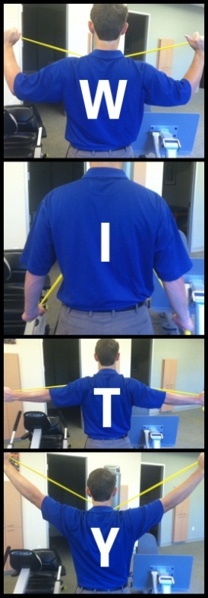

W.I.T.Y. Standing with Band
- W: Elevate arms lifting elbows to shoulder height, externally rotate to form "W"
- I: Pull hands down toward hips to form "I"
- T: Hands away from body, thumbs pointing behind you form "T"
- Y: Raise arms overhead slightly away from vertical, form "Y"
- Don’t allow the straight arm to drop as you are performing the repetitions.

Hip
With throwing you load into your trail hip and the push off onto the lead hip. If you don’t have adequate strength and stability you will get a break down of your throwing motion putting increased stress on the shoulder. Perform 3 sets of 10 repetitions for the exercise unless otherwise noted.
Step Ups
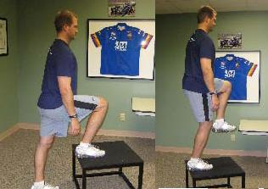
- Start with foot up on step or object.
- Press through your heel, straighten your knee, and drive your opposite knee up towards the ceiling.
- Slowly return to starting position.
- Don’t allow the knee that is on the step to pass the toes. Keep your body upright the whole time. Don’t allow your shoulders to shift forward as you step up/down.

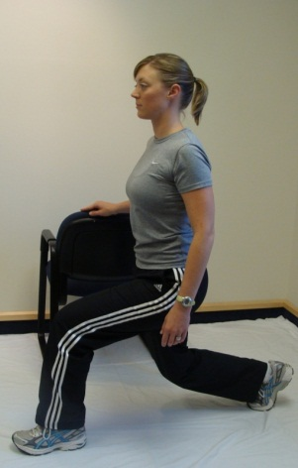
Step Back Lunges
- Start in standing position with hands on hips.
- Bring one leg behind you. With those toes on the ground bend that knee down towards the ground.
- Keep body upright while maintaining your shoulders over your hips
- Slowly return to starting position.
- Don’t allow your front knee to pass your toes. Don’t allow your back knee to touch the ground.

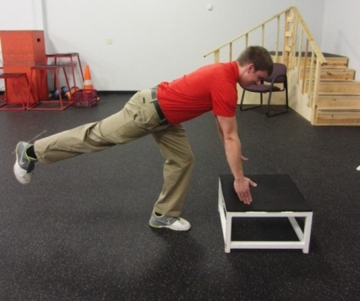
Single Leg Romanian Dead Lift
- Start in standing position. Keep your upper body in straight line.
- Slightly bend the knee of the leg you are standing on and reach for the ground in front of your toes.
- Squeeze your shoulder blades together and kick opposite leg back to maintain your balance.
- Keep the pressure in the heel of the leg you are standing on.
- Slowly return to starting position.

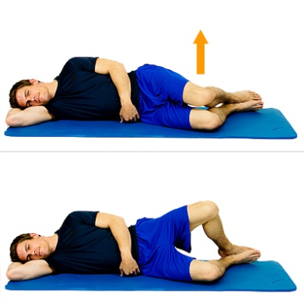
Clams
- Lay on your side with your knees bent.
- Rotate top knee up towards ceiling while keeping feet touching.
- Slowly return to starting position.
- Don’t rotate your torso back as you open your hip. Keep the motion isolated to your hip joint.

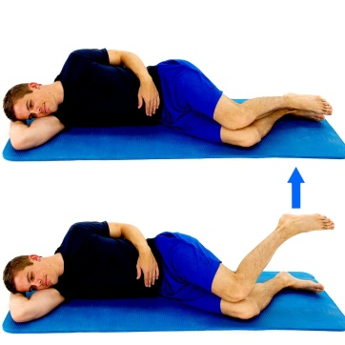
Reverse Clams
- Lay on your side with your knees bent.
- Rotate your foot up towards the ceiling while keeping your knees touching.
- Slowly return to starting position.
- Don’t rotate your torso forward as you open your feet. Keep the motion isolated to your hip joint.
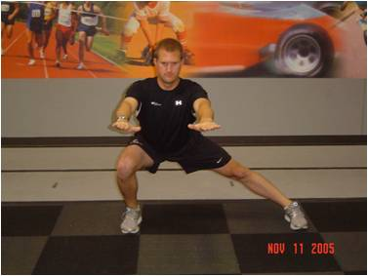
Side Lunge
- Start in standing position with hands on hips.
- Step out to the side and shift your weight towards that foot keeping the pressure in your heel.
- Load into your hip and don’t allow your knee to go in front of the toes. Keep leg straight that you are stepping away from.
- Slowly return to starting position.
X-Walks
- Step on piece of tubing and keep it in line with the arches of your feet. Cross it in front of you making an X and hold the ends of the tubing. Get into squat position and maintain that position as you take steps to the side.
- Don’t drag your feet, don’t allow your feet to touch on another, always maintain tension in the tubing.
- Take 15 steps to the right and then 15 to the left facing the same direction the whole time. 3 sets.

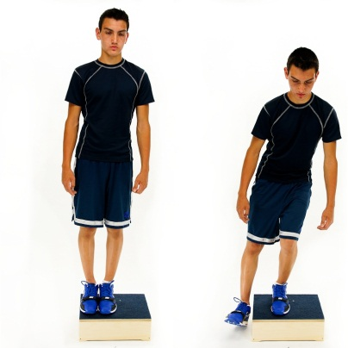
Side Step Down
- Start with both feet on top of a step/box.
- Slowly lower the outside leg down off the side of the step/box to lightly touch the heel to the floor.
- Return to the original position with both feet on the step/box.
- Maintain proper knee alignment: Knee in line with the 2nd toe and not passing in front of the toes.
Squats with Abduction
- Start in standing position with tubing around your knees and your hands out in front of you.
- Go into squat position like you are sitting into a chair.
- Press your knees out into tubing throughout motion. Do not allow your knees to come together.
- Return to starting position.

Abdominals
The core muscles transfer the energy created by your legs into your arm. A strong core will also give the athlete a more stable base and allow for improved shoulder motion without putting stress on the supporting structures of the shoulder.
Penguin Sit Up (3 sets of 25 reps)
- Lay on your back with your knees bent, feet together, and hands by your side.
- Crunch up and hold the crunch. While in that position bend sideways and reach for right foot with right hand. Then reach for left foot with left hand.
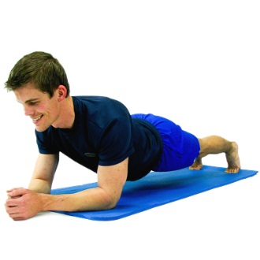
- Rotate back and forth while staying in crunch position.
Plank (3 sets of 30 seconds)
- Get into plank position pressing through elbows and toes. Maintain a flat back position and hold.
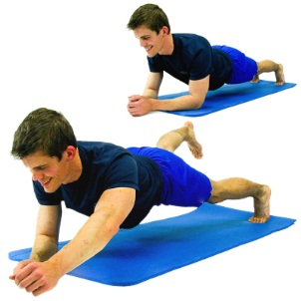
- To increase difficulty, hold for longer periods of time.
- To increase difficulty, lift up one arm and opposite leg. Return to original position and then perform with the other arm and leg.

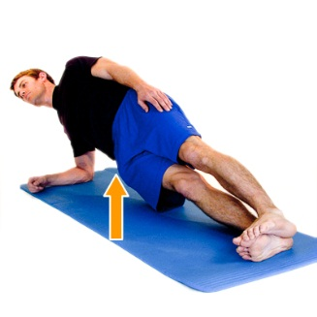
Side Plank (3 sets of 30 seconds)
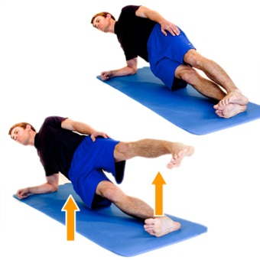
- Lay on your side propped up on your elbow and your legs out straight in-line with your torso. Stack feet on top of each other
- Push through your elbow and feet and raise your hips up off the table still keeping them in-line with your torso.
- Slowly return to starting position.
- To progress this position you can lift the top leg up towards the ceiling like you are doing a side lying hip abduction.
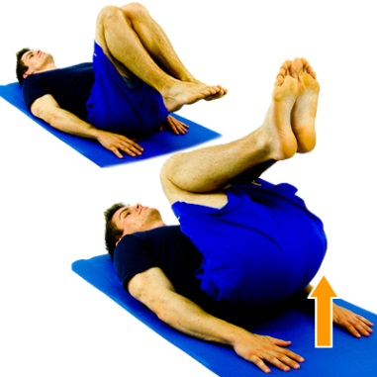
Reverse Crunch (3 sets of 25)
- Lay on your back with your knees bent and your hands across your chest or behind your head.
- Bring knees to chest while maintaining a good abdominal contraction (don’t allow your low back to arch).
- Slowly lower feet back to table, don’t allow your back to arch as you lower your legs.
Proprioception
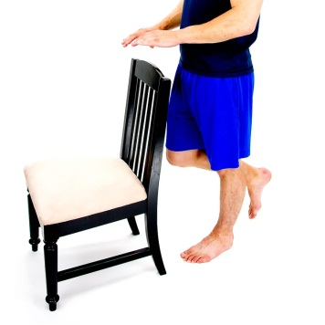
Proprioception is the body’s way of knowing where your limbs are in space. If you close your eyes, you have a general sense of where your hands and feet are. It is important to train this so your body knows where your limbs are. This will allow you to react better to positions that could be harmful.
Single Leg Stance (3 sets of 30 seconds)
- Stand on one leg with other thigh parallel to ground. Hold for 30 seconds, 3 sets. Hold for longer as it gets easier.
- To increase difficulty you can; close your eyes, swing leg that is not in contact with the ground, stand on unstable surfaces like a pillow or sand.

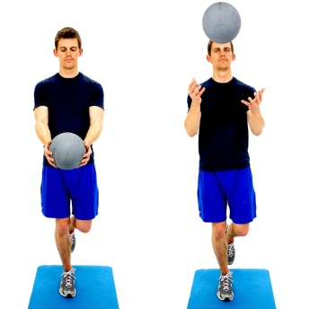
Single Leg Stance with Ball Toss (3 sets of 30 seconds)
- Stand on one leg with opposite thigh parallel to ground.
- Throw a ball in the air and catch it while maintaining your balance. You can also toss a ball with a partner
- Can be made more difficult by increasing weight, or by standing on a more unstable surface like a pillow or sand

